**Project 3 – Visualization Project Proposal**

**Group:** Heather Dietrich, Akbar Zeeshan Khan, Chenghao Han, Fatima Mukaddam

**Topic:** COVID-19impacts North America and Globally

**Repository:** <https://github.com/chenghaohan/app_Project>

**Data:** Jan 1st, 2020 – Jan 31st 2021

* New York Times
* Yahoo Finance
* Johns Hopkins
* Stats Canada

**Visualizations:**

1. Map of Canada (broken by province):

* Cases (layer/dropdown)
* Deaths (layer/dropdown)
* Vaccines (layer/dropdown)

1. Canadian Trend timeline graph - show trend over time when click on province

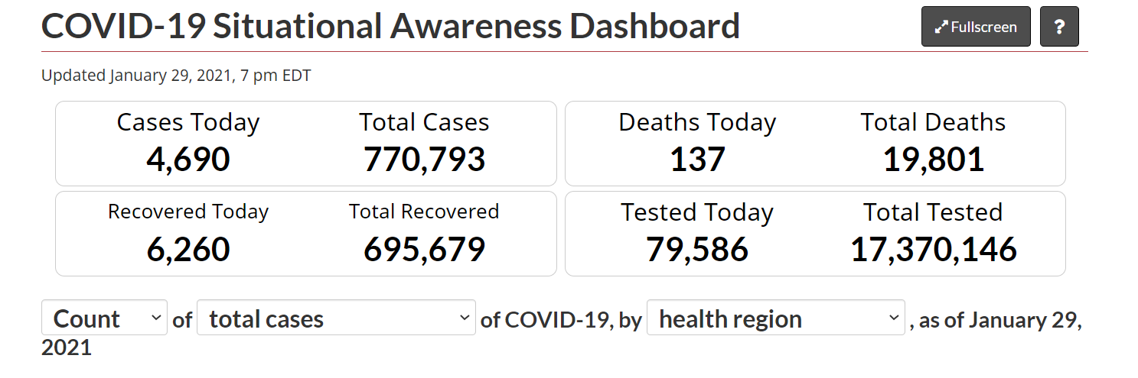

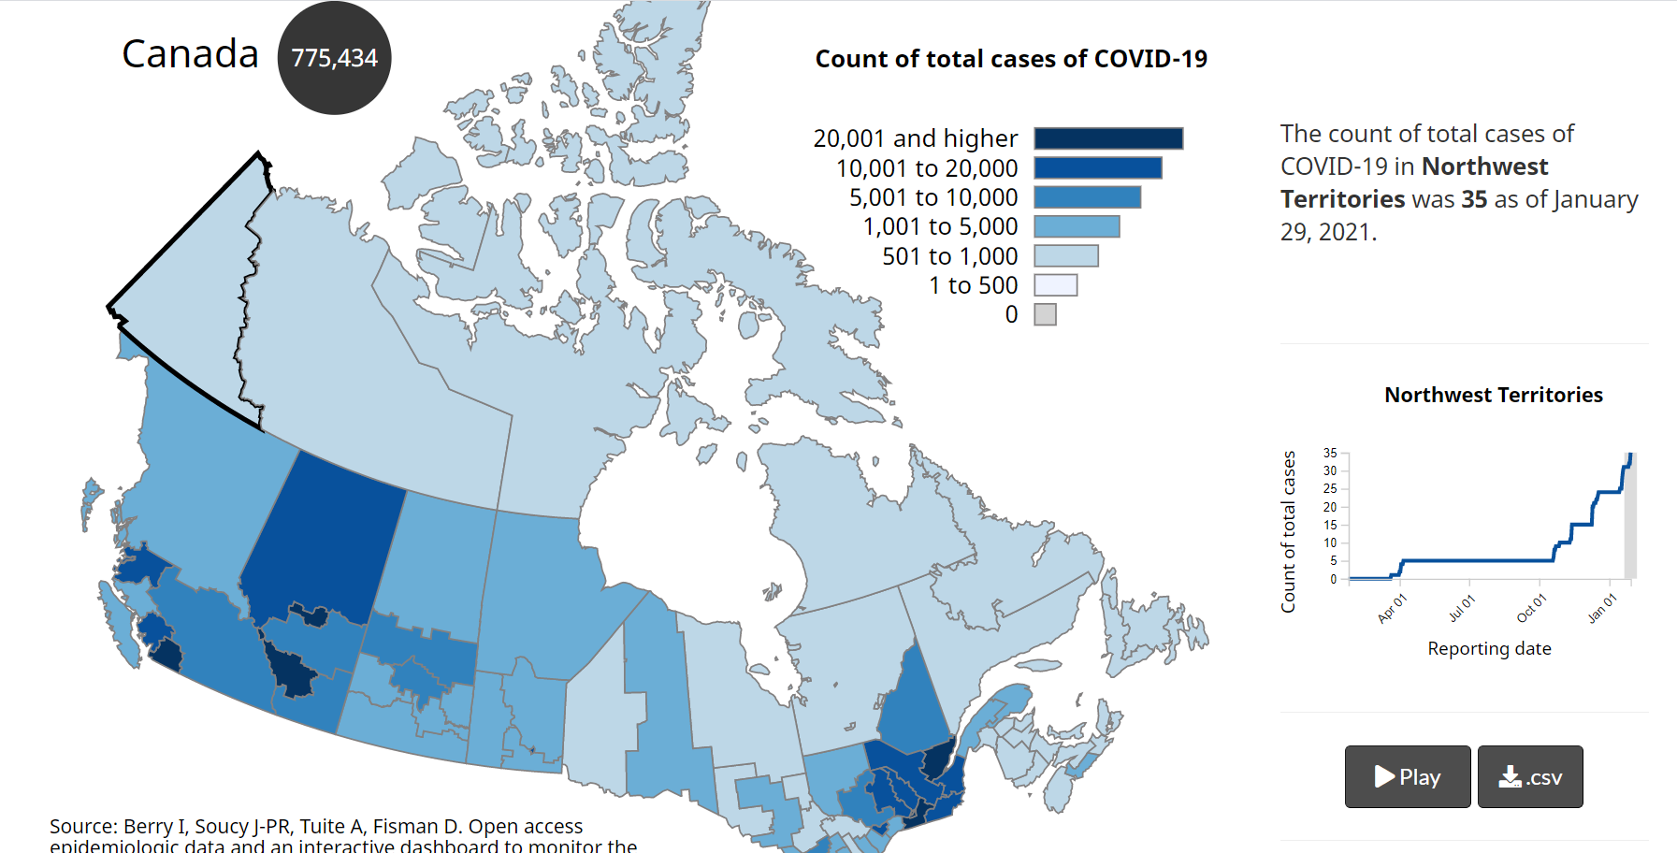

1. Map of World:

* Cases (layer/dropdown)
* Deaths (layer/dropdown)
* Vaccines (if available)
* Summary data at top

1. Global Trend timeline graph – show trend over time when click on country

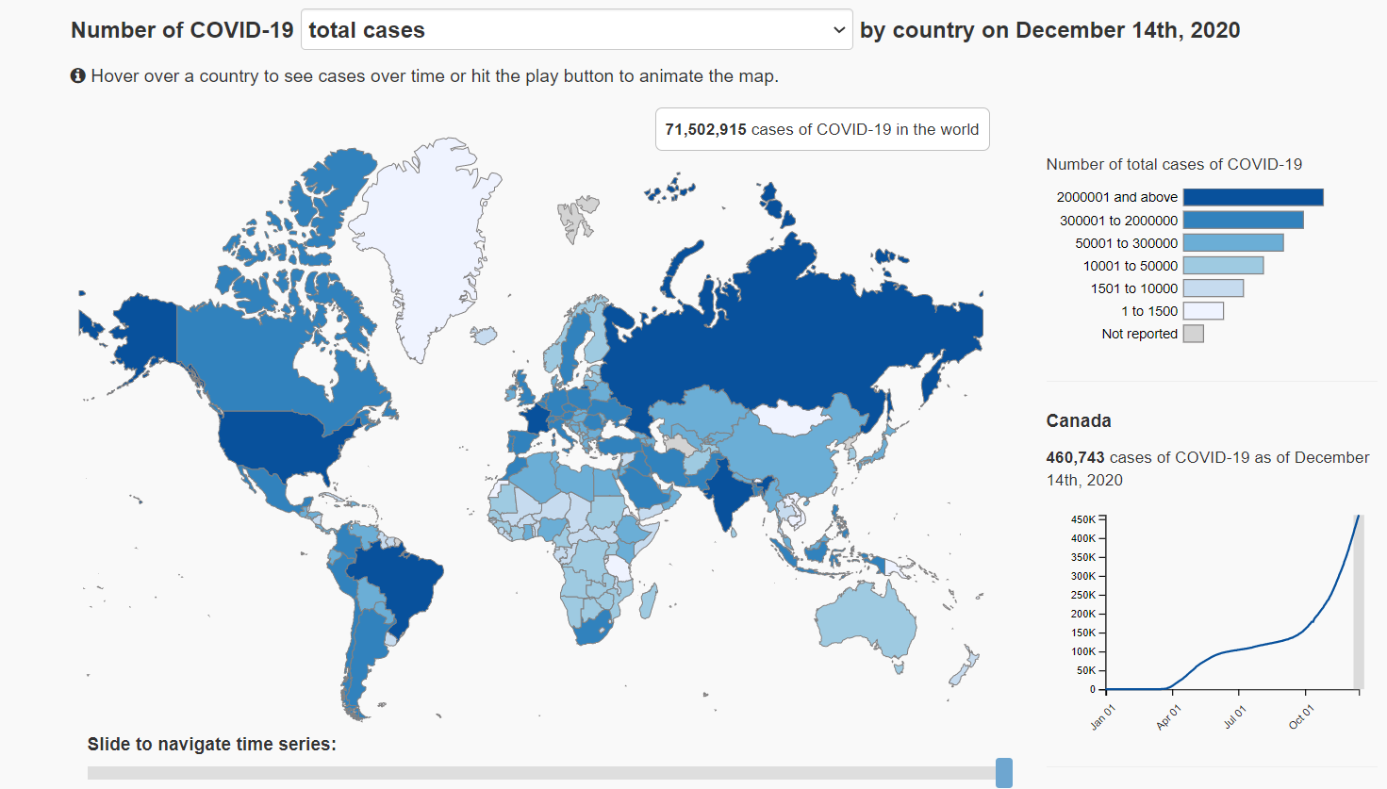

1. Stock Prices Visualization (Technology Stocks)

* Drop down for each stock
* Link to NYT timeline news data by date to link with COVID-19 (popup)

